Title of the portrait  Artist name | Ellie by Natalia Bencicova  From the series The Rite, 2019 © Natalia Bencicova  Paste in the image you are analyzing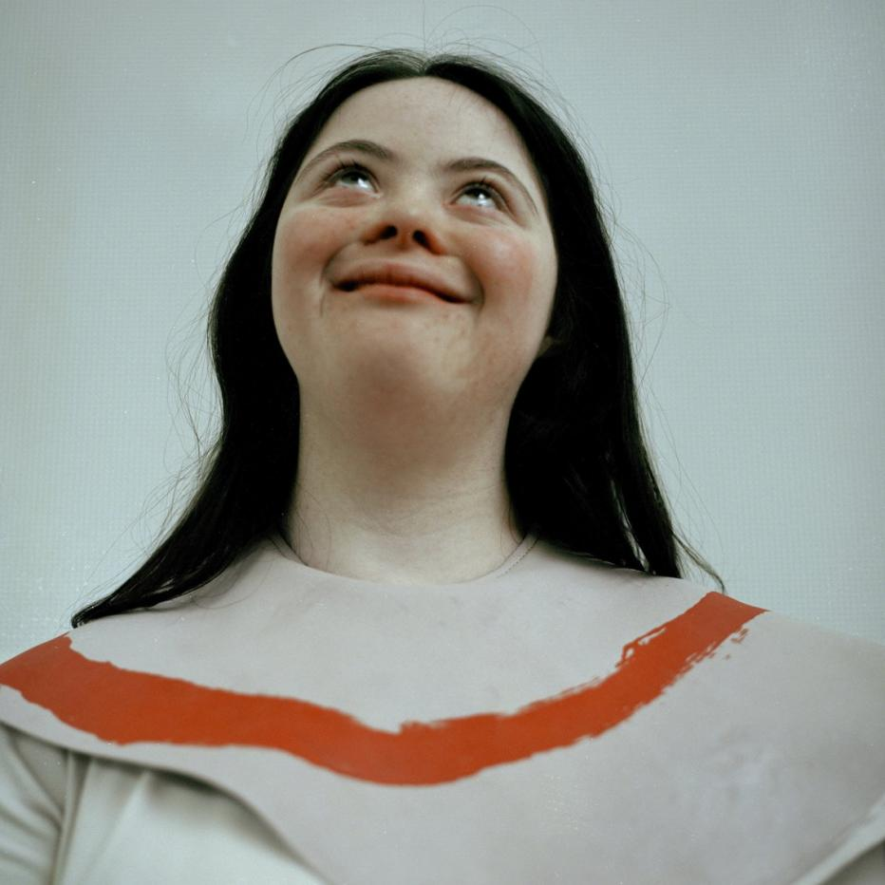
ㅡ  Why did you select it? | It is a picture which could tell many stories.  You can write here what made you analyze this particular image (topic, technique, theme, mood, genre, anything else?) What makes it stand out?
ㅡ  Theme and Tone | chaotic which in the steady environment  What did it make you feel ? / What was the main emotion of this piece?
ㅡ  Technique | The light is form the above, and the vision of the character is pointing up. The whole picture looks normal at the first glance, but it became strange when I observe for a while. The clothe which the women wear on her neck is like the clothe wear on the baby which provide the children make their clothe become dirty when they are eating. In addition, the color of the light is cold and bright. This kind of the light are always appears in the place like hospital and the construction place. For the camera angle, the artist used the low camera angle. This gives the viewer a sense of pressure.  What was the technique ? Was the technique suitable with the content ? How colors, lighting contributed to the tone? How was the sitter framed?
ㅡ  Last thoughts | It is a great picture.
 | Would you recommend it to someone ? Was it interesting ? Thought provoking? Is it relatable ? What could perhaps be done differently ?

